**Solve the practice problem on a piece of paper with your name, signature and registration number on top of the page. Take a snapshot of your solution and paste it in this document and submit it.**

Q: Run the SCC algorithm on the following graph. Choose the vertices in alphabetical order wherever choice occurs.

Show all the calculations as done in the class.

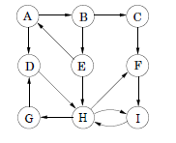

**Ans:**

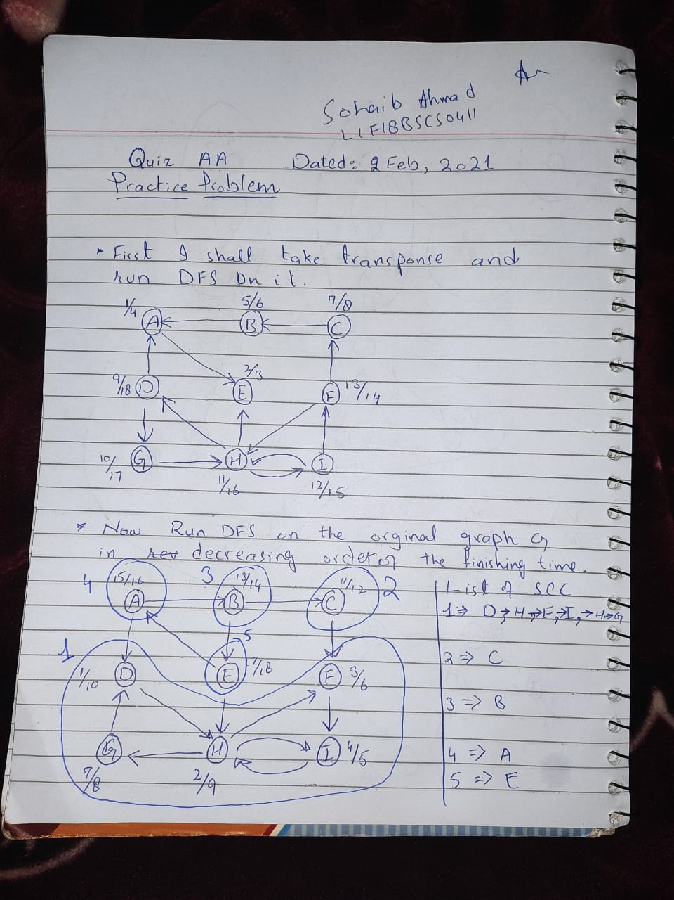

I Forgot to draw a line…

I draw it in black again.

